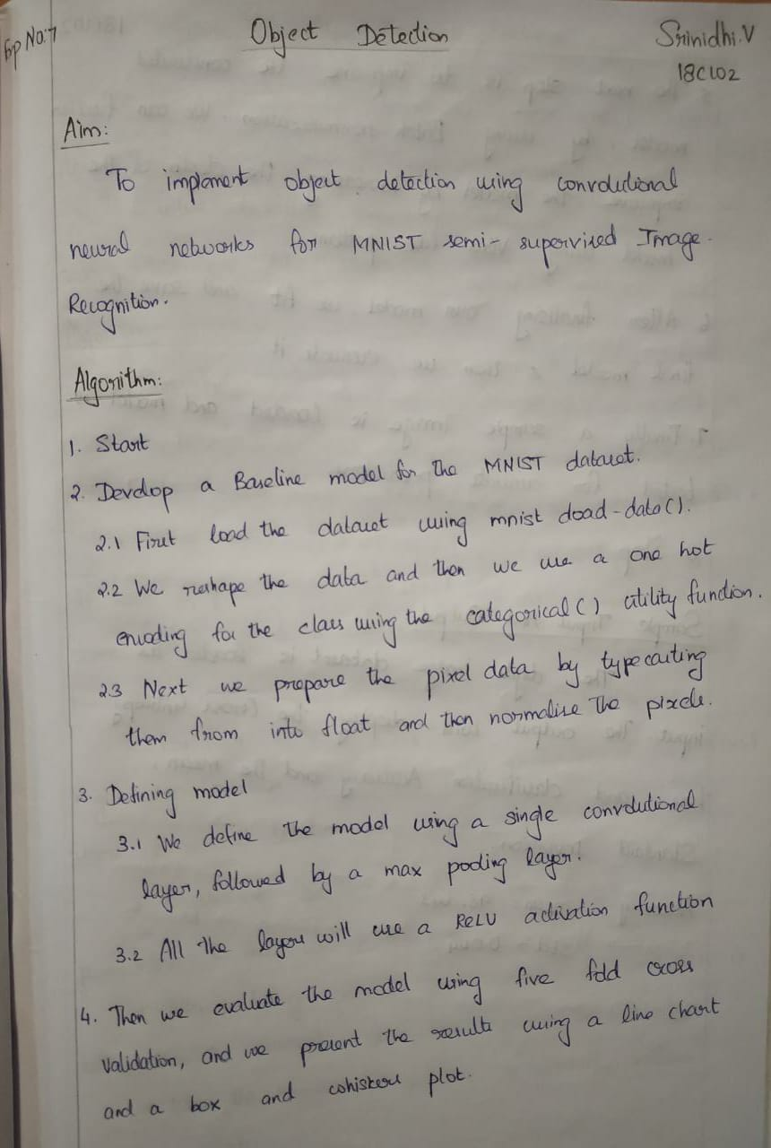

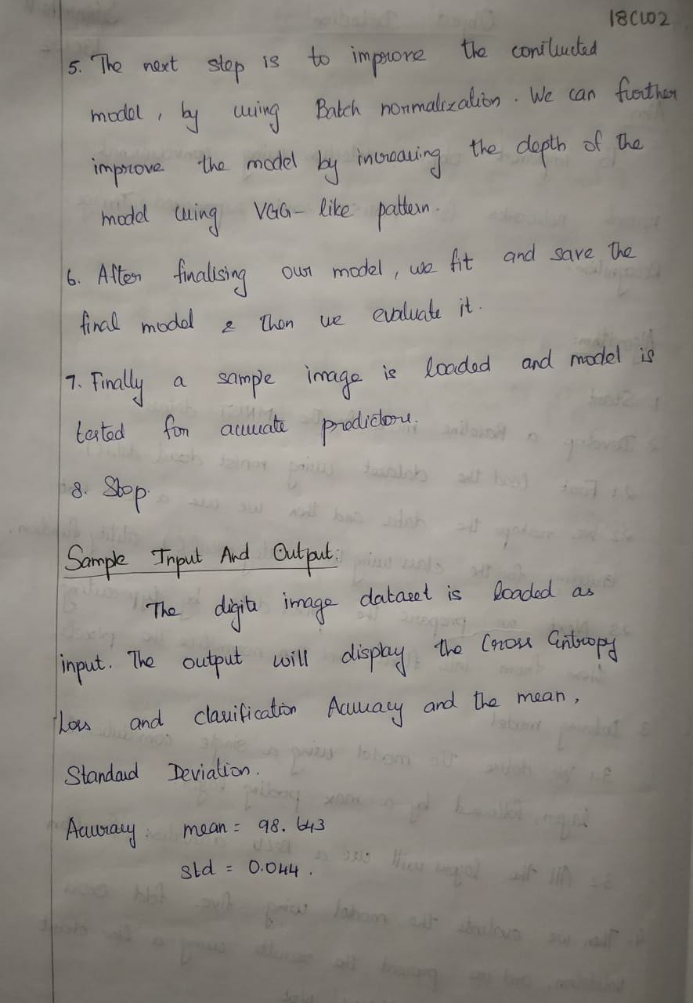

**Program:**

from numpy import mean

from numpy import std

from matplotlib import pyplot

from sklearn.model_selection import KFold

from keras.datasets import mnist

from keras.utils import to_categorical

from keras.models import Sequential

from keras.layers import Conv2D

from keras.layers import MaxPooling2D

from keras.layers import Dense

from keras.layers import Flatten

from keras.optimizers import SGD

def load_dataset():

  (trainX, trainY), (testX, testY) = mnist.load_data()

  trainX = trainX.reshape((trainX.shape[0], 28, 28, 1))

  testX = testX.reshape((testX.shape[0], 28, 28, 1))

  trainY = to_categorical(trainY)

  testY = to_categorical(testY)

  return trainX, trainY, testX, testY

def prep_pixels(train, test):

  train_norm = train.astype('float32')

  test_norm = test.astype('float32')

  train_norm = train_norm / 255.0

  test_norm = test_norm / 255.0

  return train_norm, test_norm

def define_model():

  model = Sequential()

  model.add(Conv2D(32, (3, 3), activation='relu', kernel_initializer='he_uniform', input_shape=(28, 28, 1)))

  model.add(MaxPooling2D((2, 2)))

  model.add(Flatten())

  model.add(Dense(100, activation='relu', kernel_initializer='he_uniform'))

  model.add(Dense(10, activation='softmax'))

  opt = SGD(lr=0.01, momentum=0.9)

  model.compile(optimizer=opt, loss='categorical_crossentropy', metrics=['accuracy'])

  return model

def evaluate_model(dataX, dataY, n_folds=5):

  scores, histories = list(), list()

  kfold = KFold(n_folds, shuffle=True, random_state=1)

  for train_ix, test_ix in kfold.split(dataX):

    model = define_model()

    trainX, trainY, testX, testY = dataX[train_ix], dataY[train_ix], dataX[test_ix], dataY[test_ix]

    history = model.fit(trainX, trainY, epochs=10, batch_size=32, validation_data=(testX, testY), verbose=0)

    _, acc = model.evaluate(testX, testY, verbose=0)

    print('> %.3f' % (acc * 100.0))

    scores.append(acc)

    histories.append(history)

  return scores, histories

def summarize_diagnostics(histories):

  for i in range(len(histories)):

    pyplot.subplot(2, 1, 1)

    pyplot.title('Cross Entropy Loss')

    pyplot.plot(histories[i].history['loss'], color='blue', label='train')

    pyplot.plot(histories[i].history['val_loss'], color='orange', label='test')

    pyplot.subplot(2, 1, 2)

    pyplot.title('Classification Accuracy')

    pyplot.plot(histories[i].history['accuracy'], color='blue', label='train')

    pyplot.plot(histories[i].history['val_accuracy'], color='orange', label='test')

  pyplot.show()

def summarize_performance(scores):

  print('Accuracy: mean=%.3f std=%.3f, n=%d' % (mean(scores)*100, std(scores)*100, len(scores)))

  pyplot.boxplot(scores)

  pyplot.show()

def run_test_harness():

  trainX, trainY, testX, testY = load_dataset()

  trainX, testX = prep_pixels(trainX, testX)

  scores, histories = evaluate_model(trainX, trainY)

  summarize_diagnostics(histories)

  summarize_performance(scores)

run_test_harness()

**Output:**

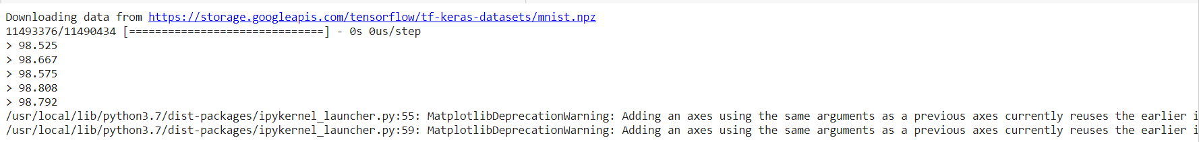

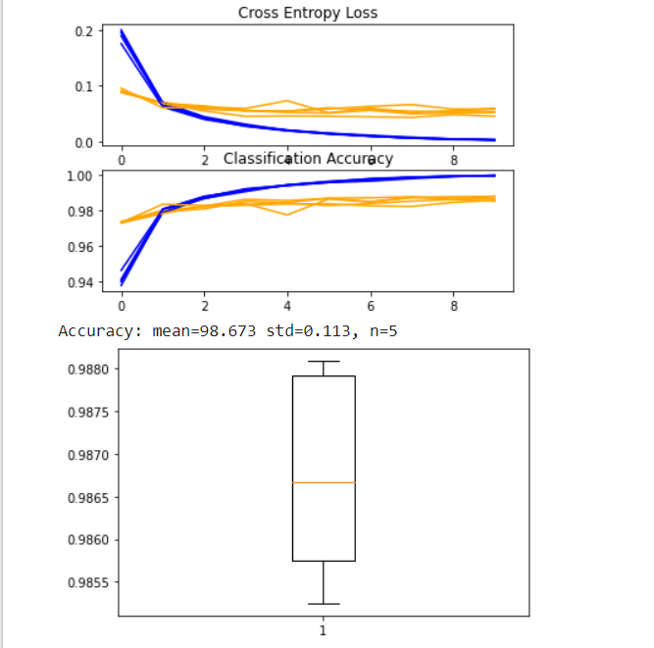

**Result:**

Thus we have implemented object detection using convolutional networks for semi-supervised Image Recognition.